Spanner visibility graph
  - Lev Nachmanson

The task
We are following (Clarkson, 1987). The difference is that we do not build the Voronoi diagram but build the spanner graph directly. Let C be a cone with the bisector parallel to the axis y and looking upwards as in Figure 1.
Figure 1: Cone C

For points a, b in plane for the purposes of our task we set d(a,b)=Math.Abs(a.y-b.y) and will call it the cone distance between a and b. For point a on the plane by C_{a} we denote cone C translated such that its apex coincides with point a. We are given a set of obstacles P where each obstacle is a convex polygon. Let V be the set of vertices of polygons from P. We call vertex u in V C-closest to v if u is visible from v, u belongs to C_{v} and d(u,v) is smallest for such vertices. Our task is to build graph G such that for every v in V with C_{v} intersected with V not empty there will be an edge (v,u) in G such that u is C-closest to v. When we rotate cone C to cover the whole circle of directions we will build the graph from (Clarkson, 1987).

Data structures
Our algorithm is a sweepline algorithm where we sweep with a horizontal line going bottom top. During the sweep the line will pass through EventSites. Each EventSite is associated with a point on the plane denoted by EventSite.p. We consider lexicographical order of the plane points where a < b iff a.y < b.y ||(a.y == b.y && a.x < b.x). We maintain a priority queue Q of EventSites where the smallest according to this lexicographical order elements will be at the top of the queue. During the sweep we construct Segments. Each Segment has the start point denoted by Segment.start and the direction denoted by Segment.dir. For each Segment we will have Segment.dir.y > 0. We will sort Segments along a sweep line. For a real number z we denote by Hor_{z} the line which points have z as the y coordinate. Let s₀ and s₁ be Segments with starts not above the line, that is s₀.start.y ≤ z and s₁.start.y ≤ z. Hor_{z} defines the order on s₀ and s₁ in the following way: s₀ < s₁ if and only if the point of intersection of the s₀ with Hor_{z} is to the left of the point of intersection of Hor_{z} with s₁, or s₀.start==s₁.start and the direction of s₀ is to the left of s₁ when looking in the direction of y-axis, see Figure 2.
s₁
s₀
Hor_{z}

Hor_{z}
s₀
s₁
Figure 2: s₀ is less than s₁ in the order defined by Hor_{z}

EventSites
Event is the base class for event classes. Event.site is the point on the plane associated with the event. There are two kinds of events: VertexEvent and IntersectionEvent. VertexEvent happens when the sweepline passes through a vertex and an IntersectionEvent happens when the sweepline passes through an intersection of two Segments.

Segments
There are two kinds of segments: ConeSides and EdgeSegments, as Figure 3 shows. In turn there are two types of of EdgeSegments: LeftEdgeSegment and RightEdgeSegment, see Figure 4. Also there is LeftConeSide and RightConeSide. ConeSide points to Segment.apex and to the other ConeSide of the cone.
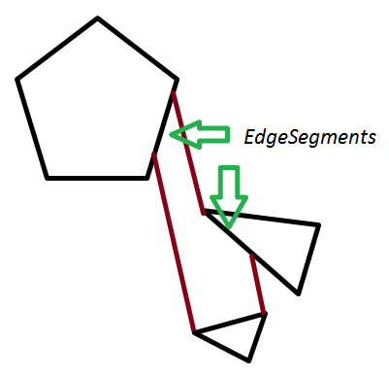
Figure 3: EdgeSegments and ConeSides
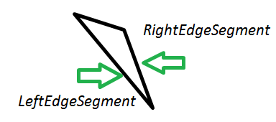
Figure 4: LeftEdgeSegment and RightEdgeSegment
EdgeSegment keeps a list of ConeSides called EdgeSegment.ObscuredConeSides of some active cones; intuitevely a segment points to a ConeSide if for the current sweepline the segment represents the side of the cone. More precisely the side belongs to the list when there is a point t on the sweepline which is outside of all obstacles, belongs to the side cone, and if we look to the direction of the cone side along the sweepline we see the EdgeSegment first, as in Figure 5.
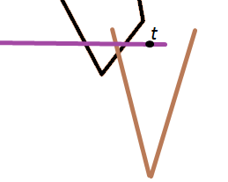
Figure 5: ObscuredConeSides

ActiveSegmentsTree
During the sweep we will keep Segments that are active in a tree T ordered by the order defined by the current Hor_{z}.

Algorithm in pseudocode
BuildGraph(){
Init();
Sweep();
}
Init(){
EnqueueAllObstacleVertices();
CreateEmptySegmentTree();
}
Sweep(){
while( Q is not empty )
ProcessEvent (Q.Dequeue());
}
ProcessEvent(EventSite event){
z=event.site.y;
if(event is VertextEvent) ProcessVertexEvent(event);
else ProcessIntersectionEvent(event);
}
ProcessVertexEvent(VertexEvent vertexEvent){
ProcessActiveConesContainingVertexEvent(vertexEvent.site);
TryToCreateConeAtVertex(vertexEvent.site);
}
ProcessActiveConesContainingVertexEvent(Point site){
The version that we present here is a bit simplified. For a Segment s we denote by s(z) the x-coordinate of the intersection of s with Hor_{z}. Let s be the first right cone side in T with s(z) ≥ site.x and s.leftSide(z)<=site.x is a such s exists, otherwise set s to null. If s is not null for each left cone side k with
k(z)>= s.leftSide(z) and k(z)<=site.x create a new edge of the spanner graph (k.apex, site) and delete k and k.rightSide. See Figure 6.
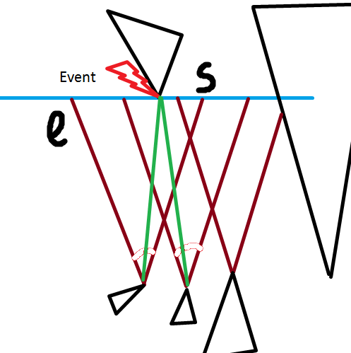
Figure 6: green edges are created and cones containing them are deleted

}
TryToCreateConeAtVertex((Point site){
}

Clarkson, K. L. (1987). Approximation Algorithms for Shortest Path Motion Planning. Annual ACM Symposium on Theory of Computing , 56-65.

